**The Equalizer & The Official Publication of Mabalacat City College**



**Sprint #4**

Members:

GUNNING, IRENE L.

LAROGA, RUSSEL Z.

FRANCISCO, JULIUS D.

NICDAO, CHONNA D.

MARIN III, RUBEN F.

QUITALIG, ADRIAN F.

SANDIG, CEEJAY T.

ARCEO, SHARMAINE C.

TEAM EQUALIZER – APRIL 27, 2017

|  |  |  |
| --- | --- | --- |
| Scrum TEAM | SPRINT NAME AND DURATION | CHANGES |
| Team Equalizer | Equalizer Sprint #4  1/Mar/17  to  27/April/17 | * **EQUA01- Issues page** * Issues are used to inform the user about what happening in our school. The admin have an authority to Create, Read, Update and Delete. |
| Team Equalizer | Equalizer Sprint #4  1/Mar/17  to  27/April/17 | * **EQUA02- View user** * View user is used to view the information of the user. The user has an authority to create an account to have an access in page. |
| Team Equalizer | Equalizer Sprint #4  1/Mar/17  to  27/April/17 | * **EQUA03- Settings**   Setting page is used to edit the information of website and also can add a new admin for the website. |
| Team Equalizer | Equalizer Sprint #4  1/Mar/17  to  27/April/17 | * **EQUA04- View website**   View website is use the admin to view the landing page of the user. |
| Team Equalizer | Equalizer Sprint #5  1/Mar/17  to  27/April/17 | * **EQUA05- Comment section and Contact**   Comment section and contact are used for the user to comment and contact us if they like or dislike that admin posted and also the website. |
| Team Equalizer | Equalizer Sprint #6  1/Mar/17  to  27/April/17 | * **EQUA06- About page**   Navigation Tab for user such as News, Opinion, Feature, Literary, Entertainment, Sports and Issues. |

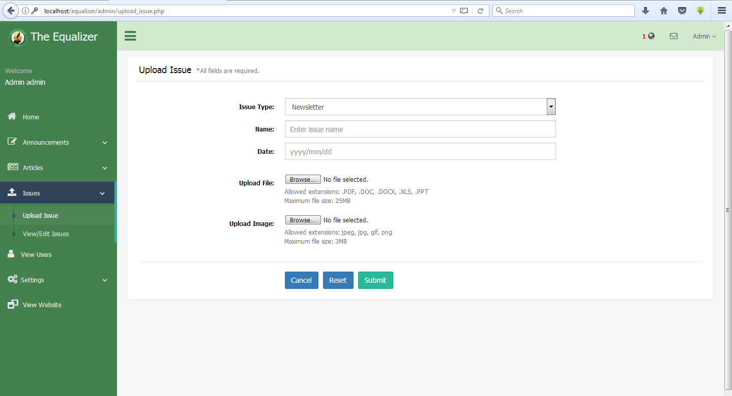**EQUA01- Issues page**

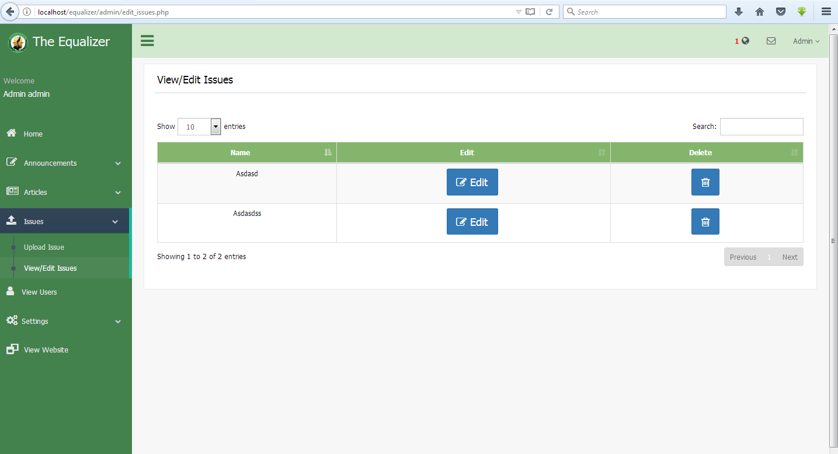

**EQUA02- View user**

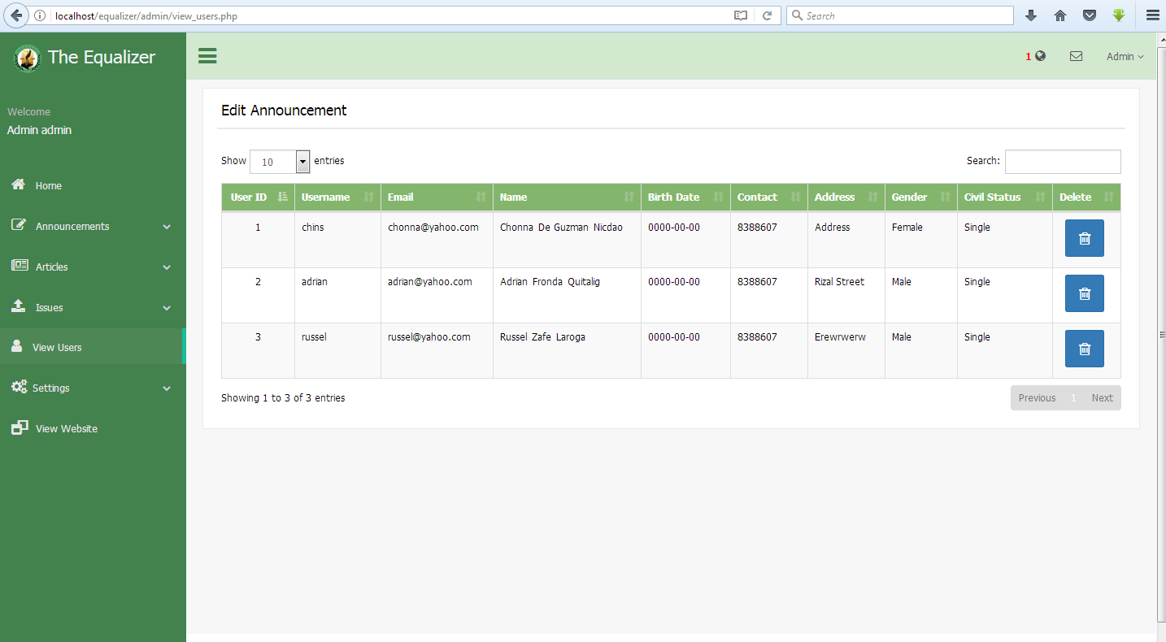

**EQUA03- Setting page**

**Edit Account**

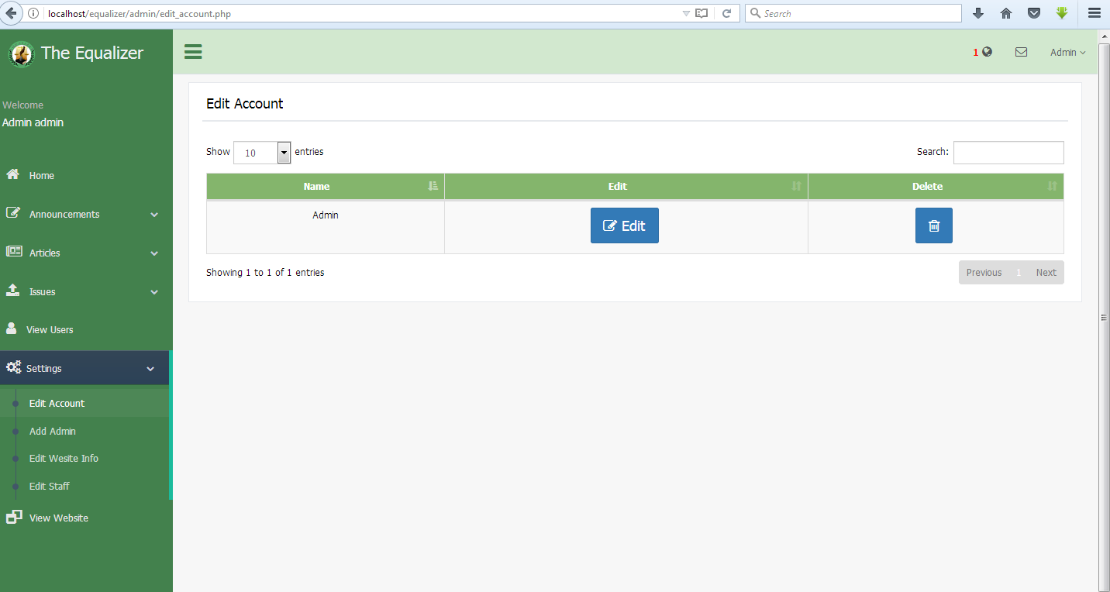

**Add Admin**

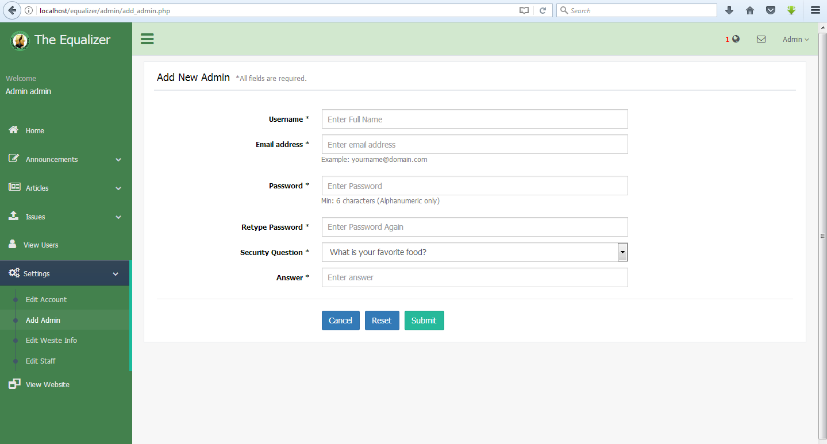

**Edit Website info**

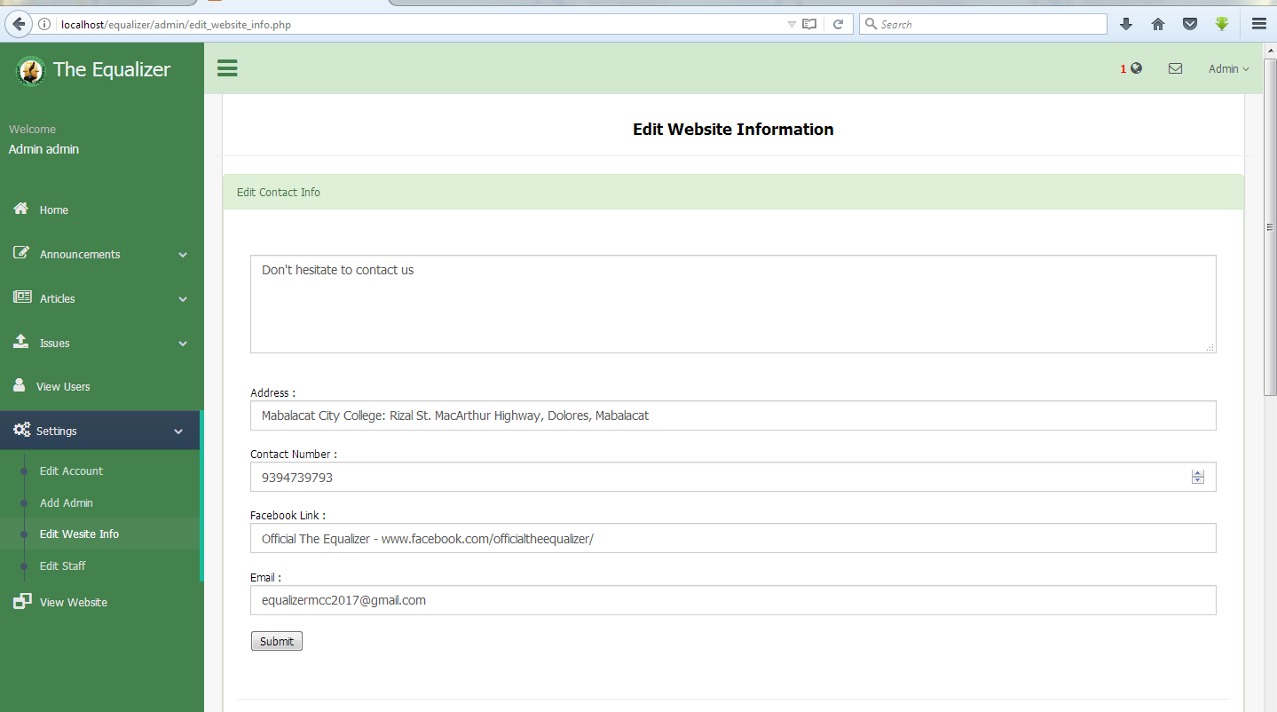

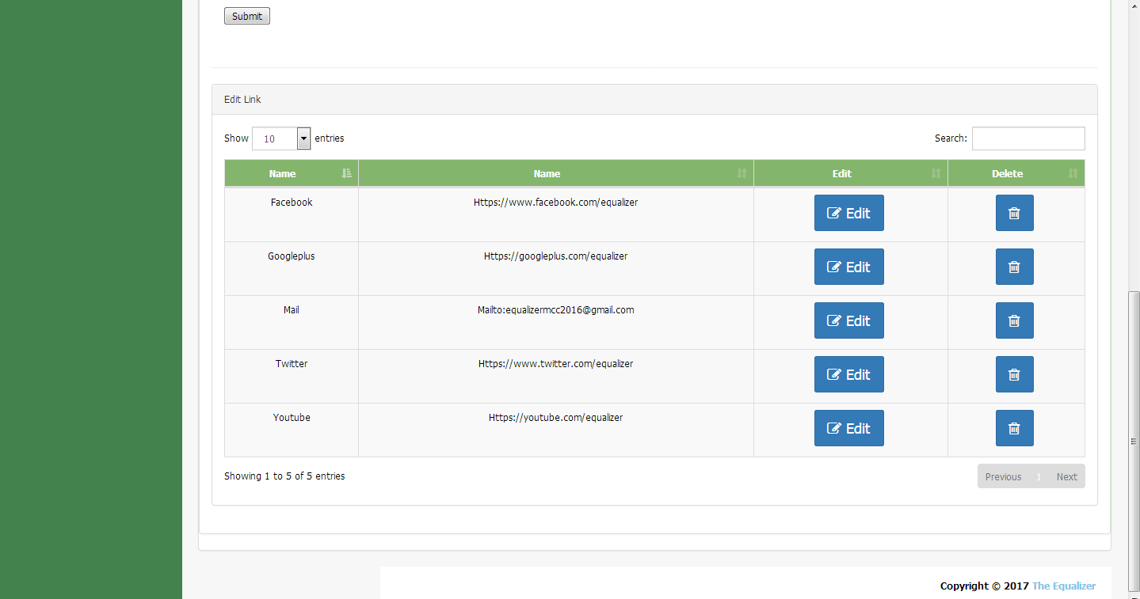

**Edit Staff**

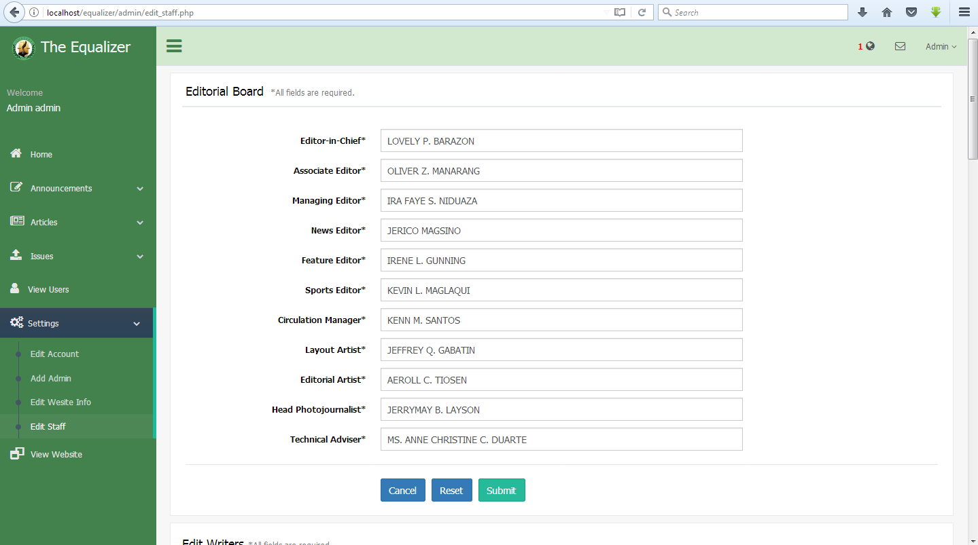

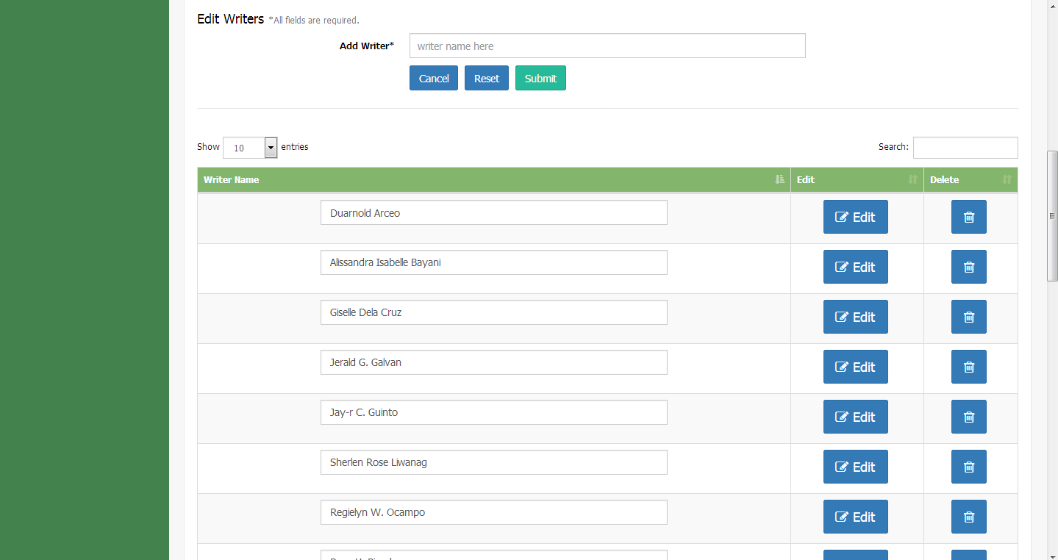

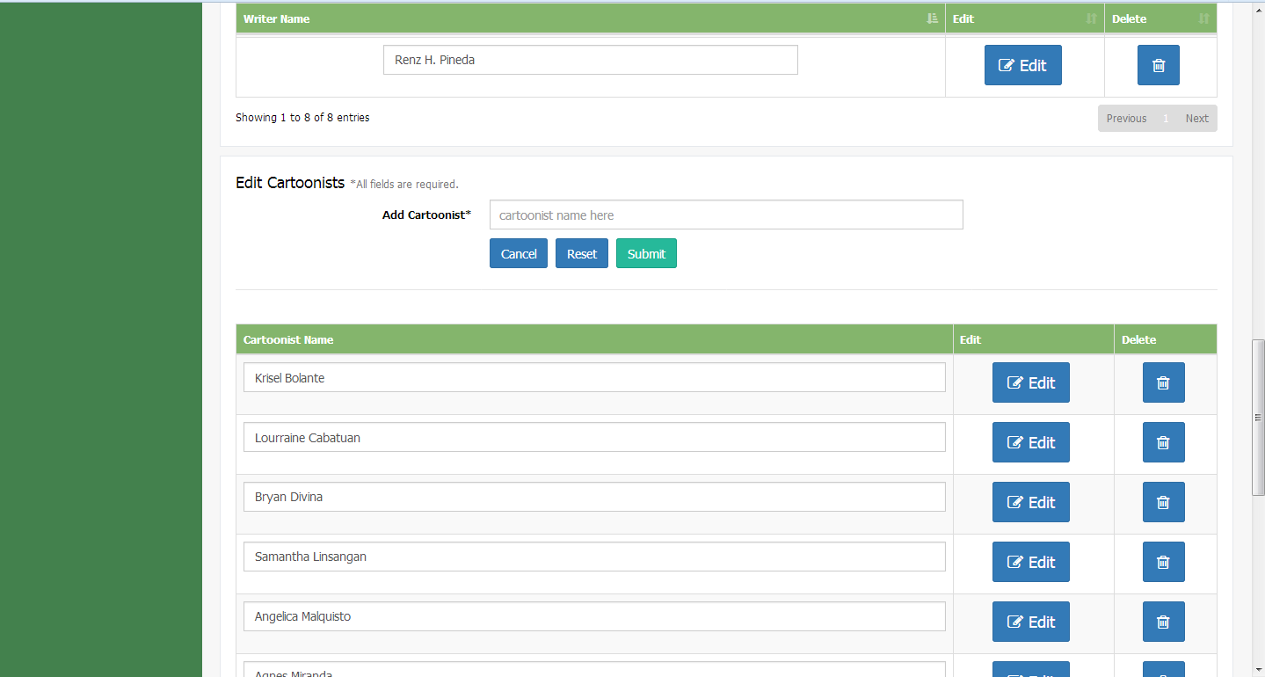

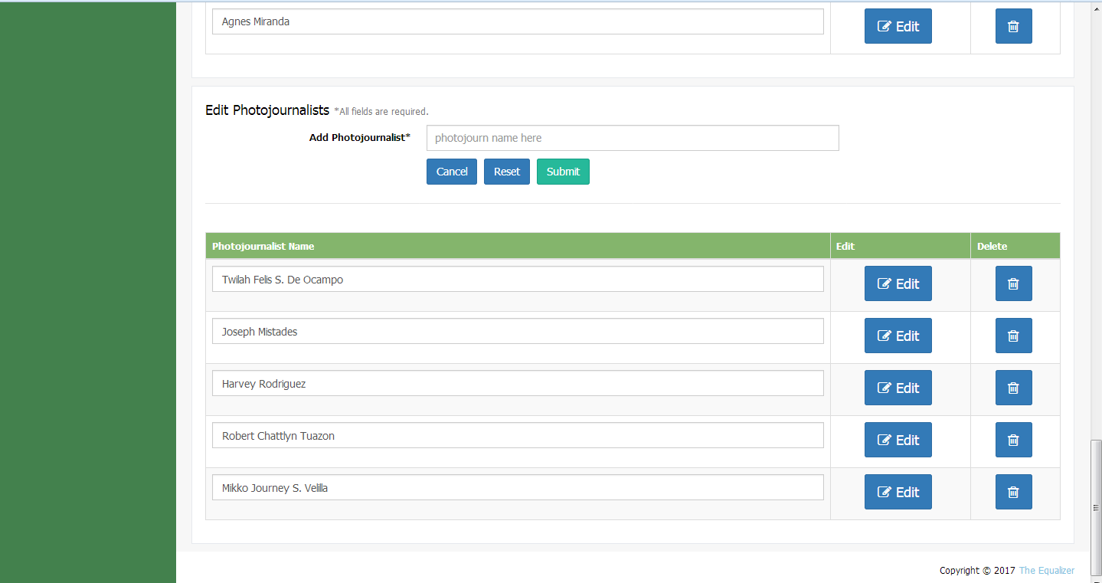

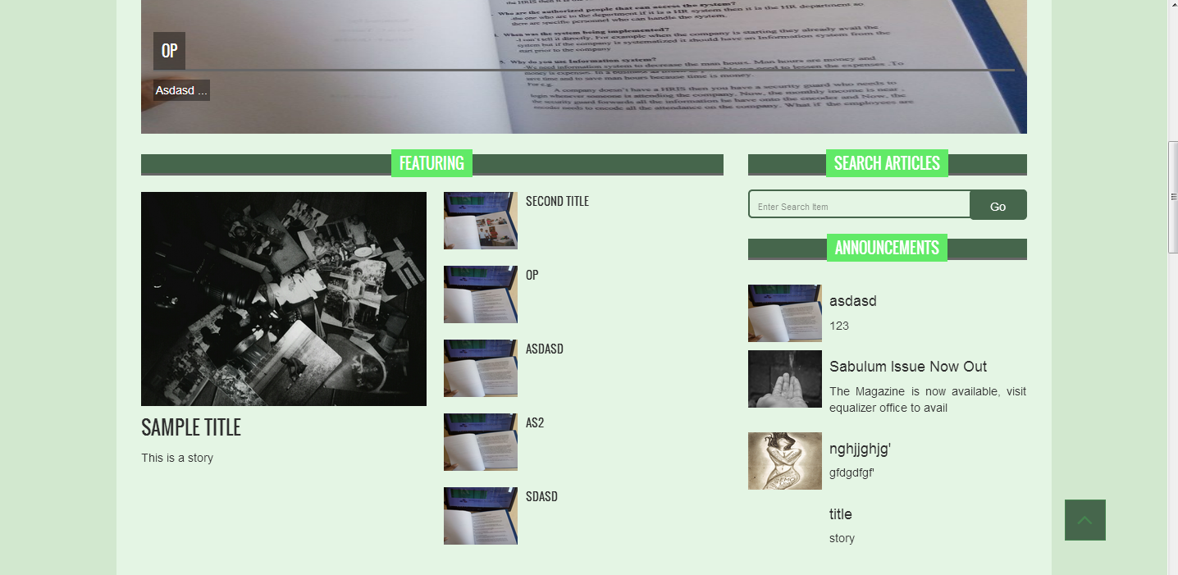**EQUA04- View website**

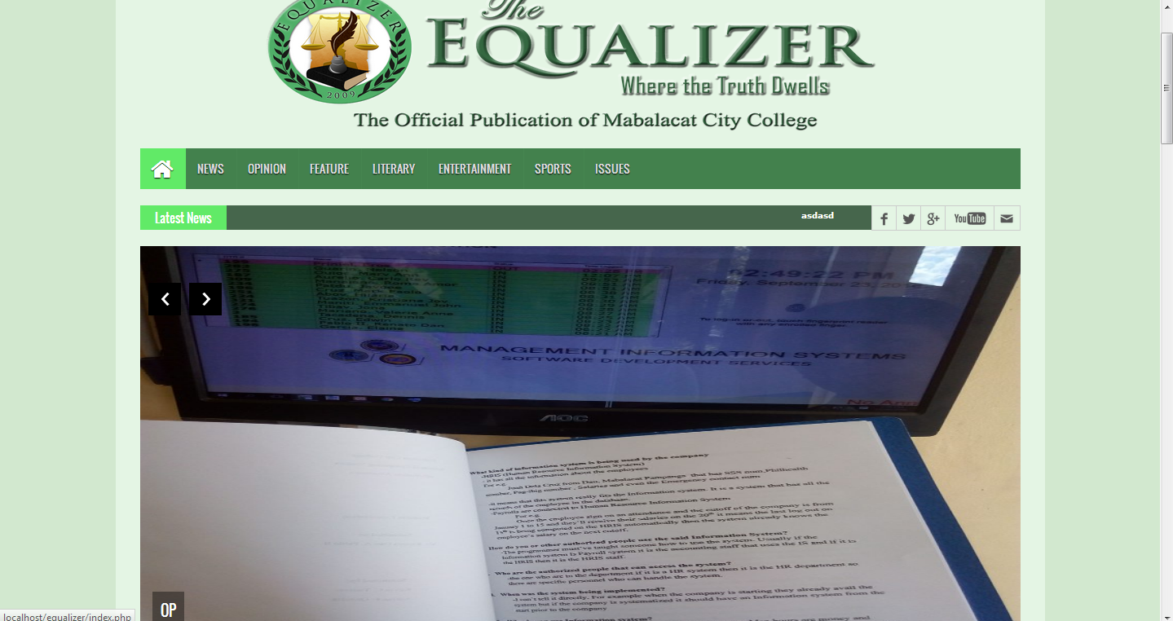

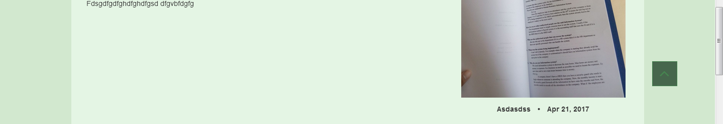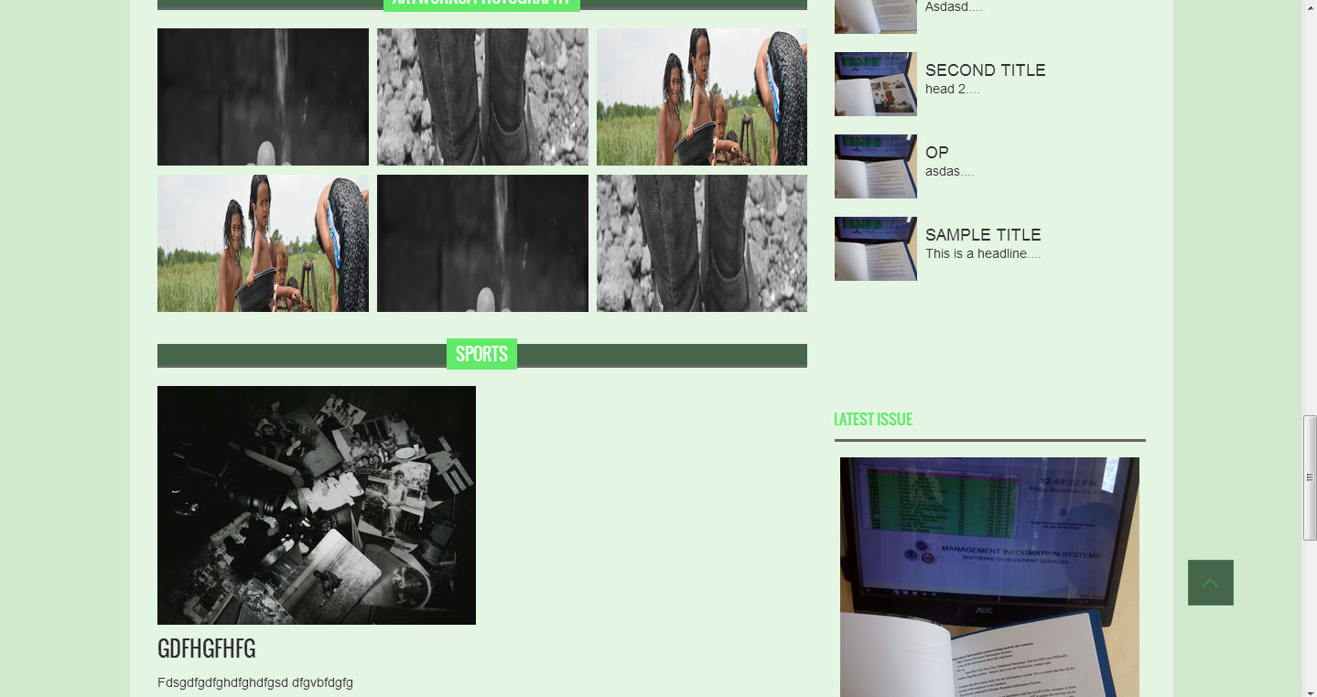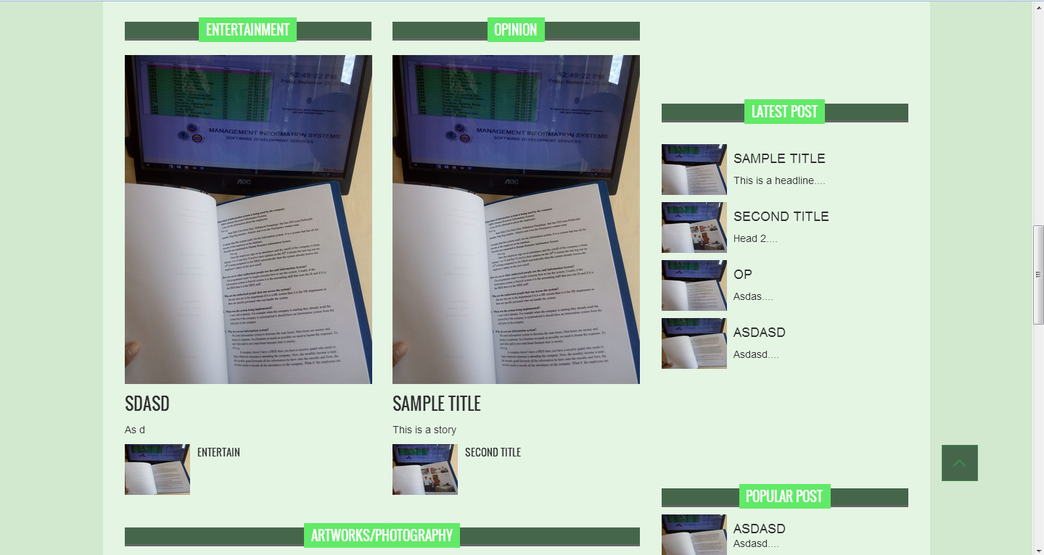

**Issues tab/Newsletter**

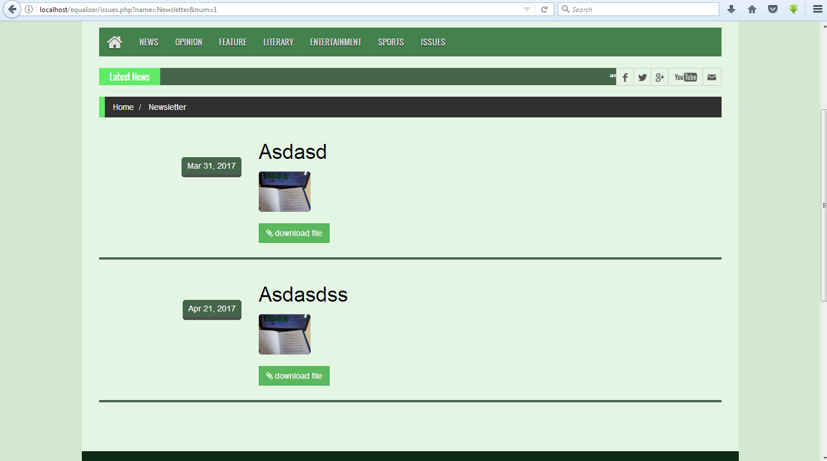

**Issues tab/Tabloid**

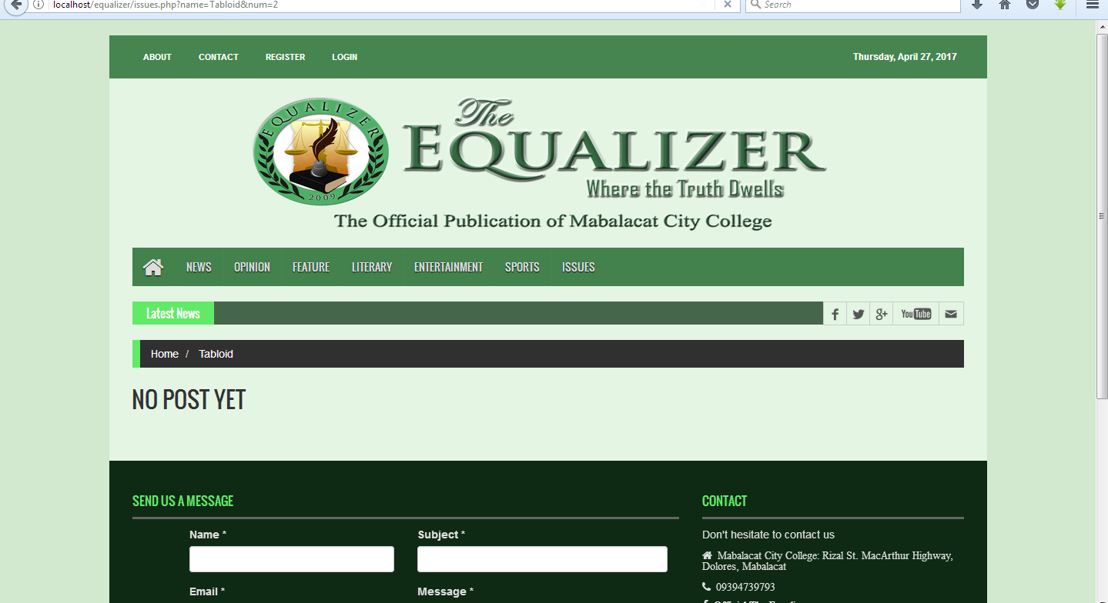

**Issues tab/Broadsheed**

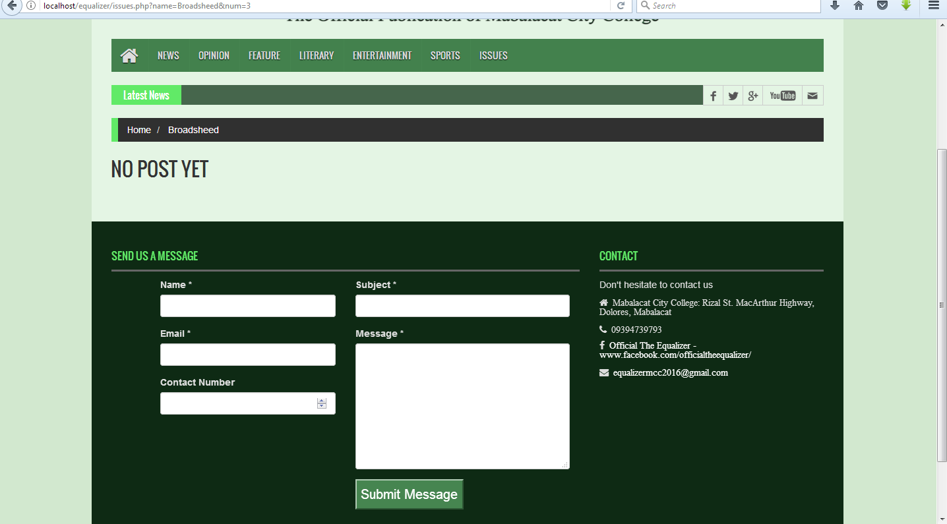

**Issues tab/Balas**

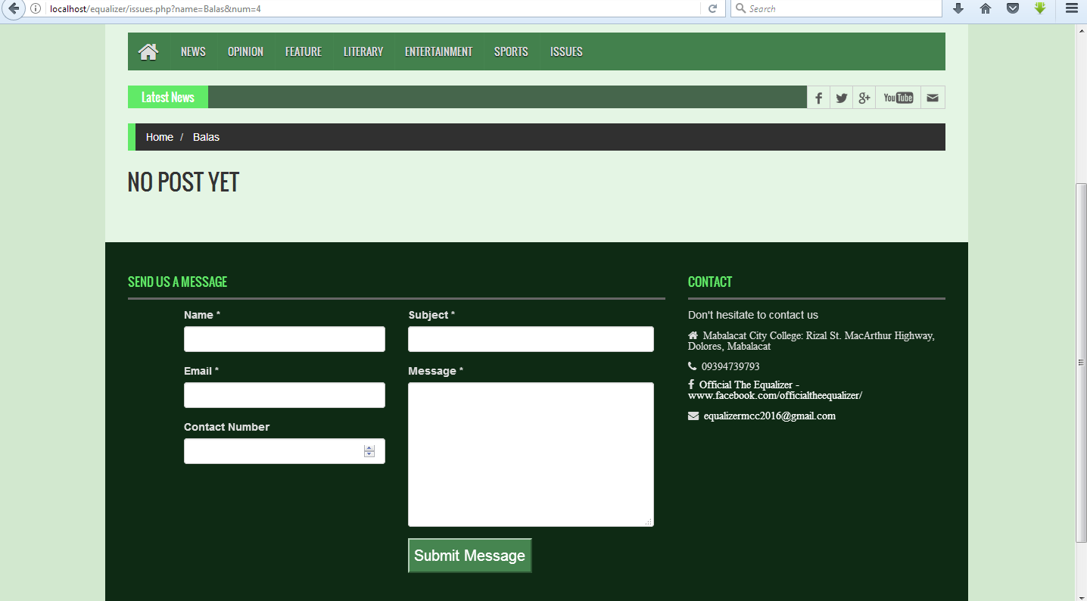

**Issues tab/Sabulum**

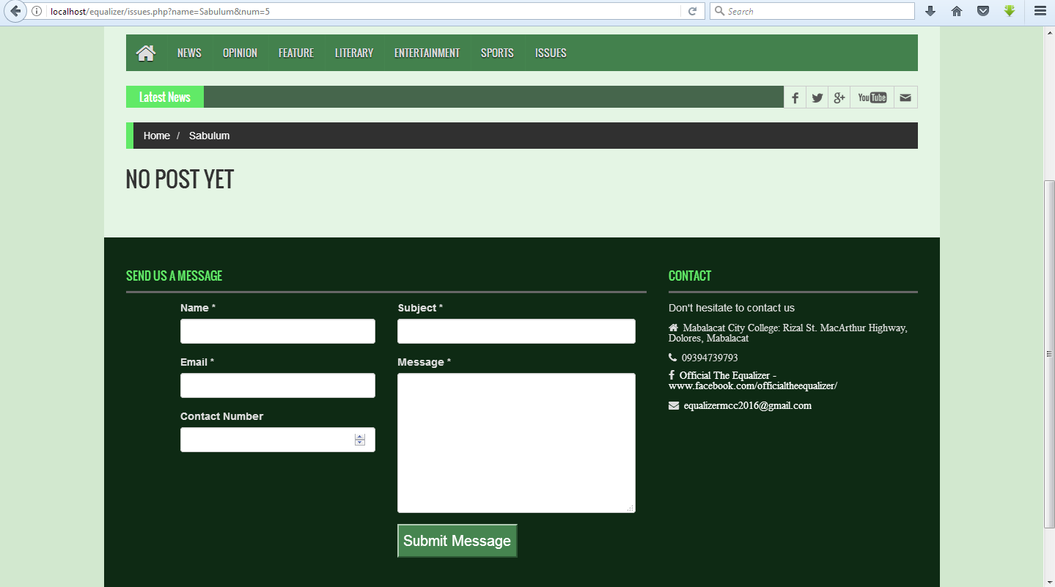

**EQUA05- Comment section or Contact**

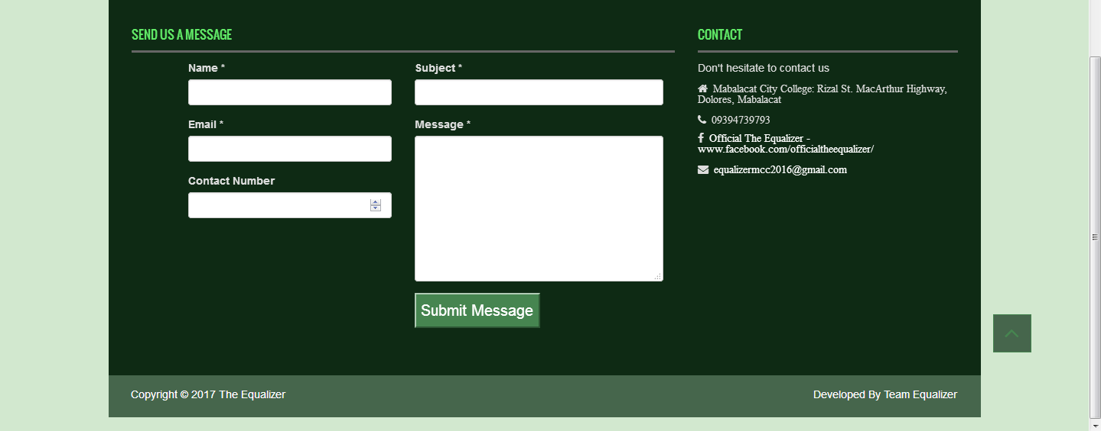

**EQUA06- About page**

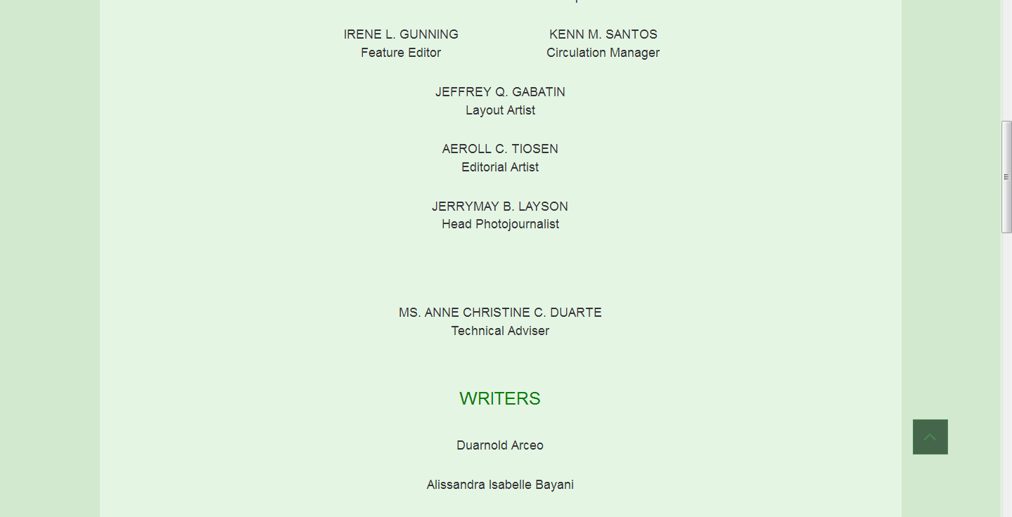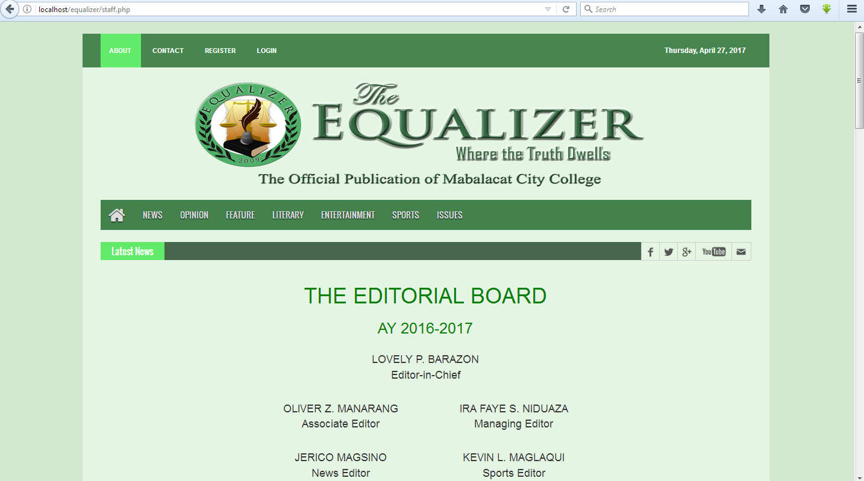**About tab/ Staff**



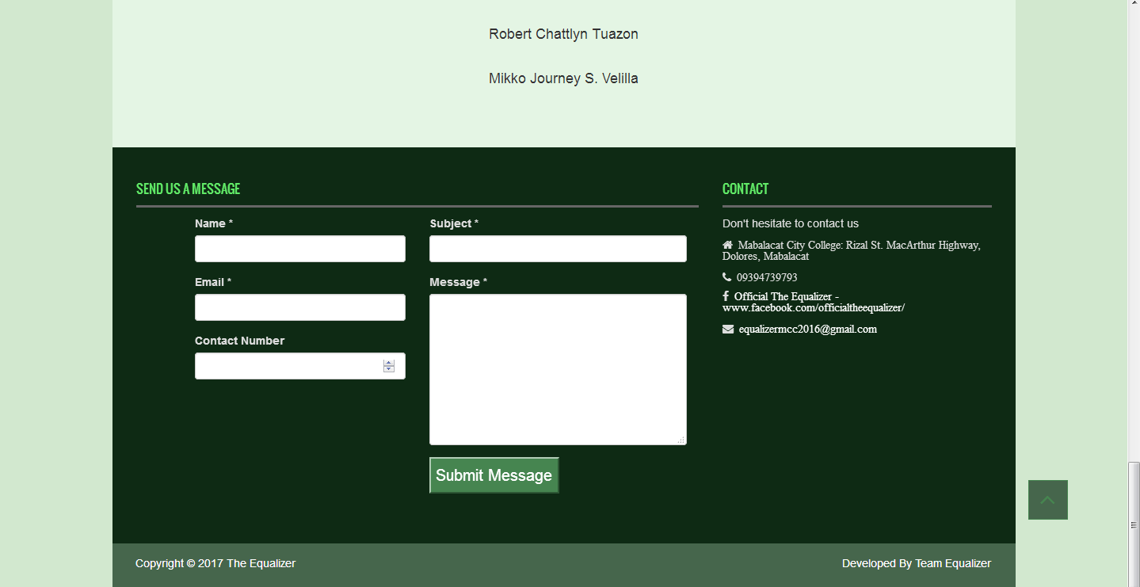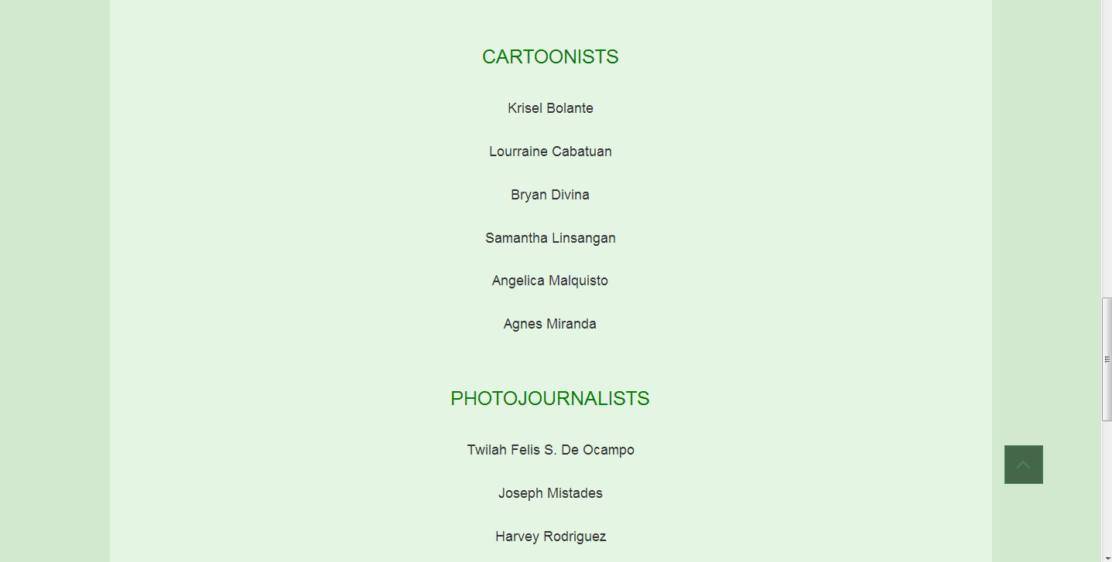

**About tab/ History**

